Philadelphia University
Faculty of Pharmacy
Phytotherapy (0510542)

MIDTERM EXAM

Date: 21.7.2019 Exam duration: 50 min

Serial class number:

Section time : الشعبة (وقت)

Lecturer: Dr. Yousef Abusamra

Name: Student number:
************************************************************************
Multiple-choice question:
 | A | B | C | D | E |  | A | B | C | D | E
1 |  |  |  |  |  | 12
2 |  |  |  |  |  | 13
3 |  |  |  |  |  | 14
4 |  |  |  |  |  | 15
5 |  |  |  |  |  | 16
6 |  |  |  |  |  | 17
7 |  |  |  |  |  | 18
8 |  |  |  |  |  | 19
9 |  |  |  |  |  | 20
10 |  |  |  |  |  | 21
11 |  |  |  |  |  | 22

TOTAL MARK:

/30
MARKS ALLOCATED TO EXAM SECTIONS:
I. Multiple-choice: / 20 ----- /15

II. Short Essay: / 15

I. CHOOSE THE MOST CORRECT ANSWER IN EACH OF THE FOLLOWING STATEMENTS? (20 X 0.75 = 15 MARKS)
1. A solution rich in which phytochemical can be used as a detergent?
- Anthocyanin.
- Saponin.
- Coumarin
- Chromone.
- None of the above.
2. The following chemical structure belongs to which phenolic group?
- Flavonol.
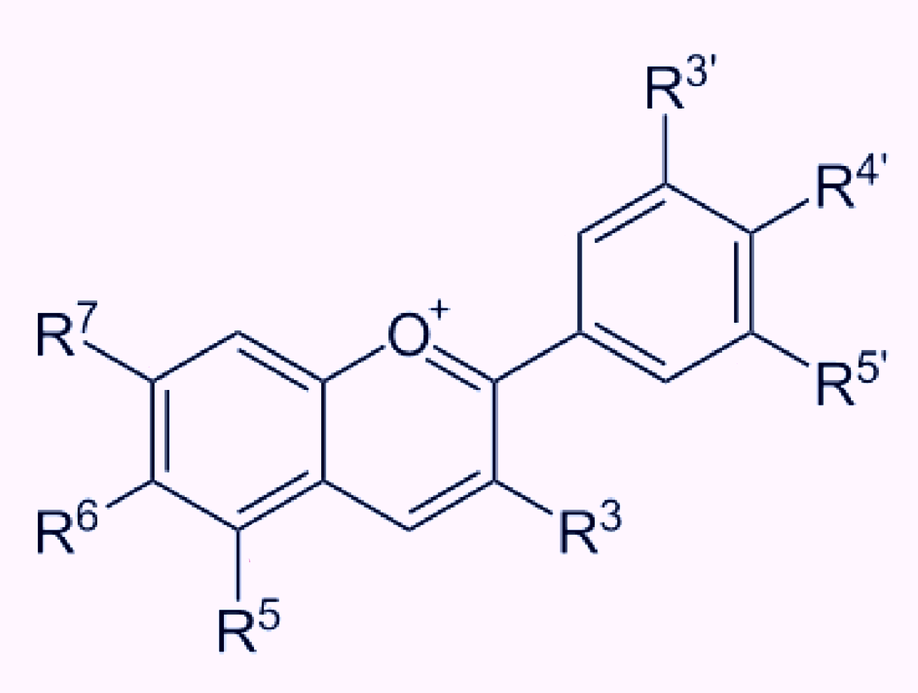
- Flavone.
- Flavonone.
- Chalcone.
- Anthcyanidin.

3. What would you prescribe for a patient at risk of retina bleeding?
- A formulation based on an extract from bilberry.
- A formulation based on an extract from white mustard.
- A formulation based on an extract from willow bark.
- A formulation based on an extract from Ammi majus.
4. While studying plant extracts, you found that an active ingredient has the following chemical structure, which of the following pharmacological effects can remarkably بشكل لافت be attributed تعزى ل to this compound?
- Anti-oxidant.
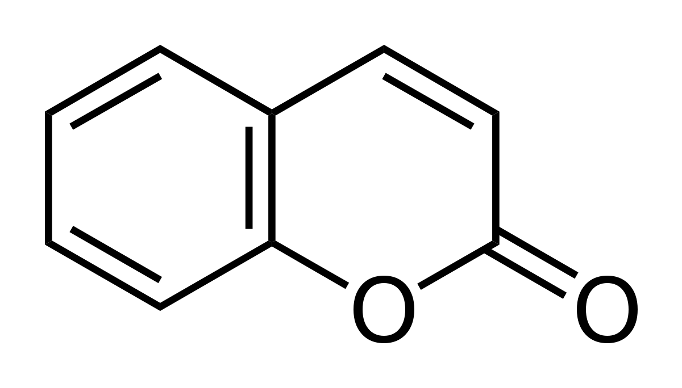
- Anti-cancer.
- Blood-thinning.
- Anti-emetic.
- Adsorbent.

5. How can you prepare vanillin in the lab?
- From isoeugenol.
- From helicin.
- From gluconapin.
- From bergapten.

6. A phytochemical having the following actions: emetic, anti-irritant and rubefacient is most possibly obtained from which plant?
- Sambucus nigra.
- Vanilla planifolia.
- Brassica nigra.
- Discorea bublifera.
7. Which of the following plants is famous for its use as a source of starch?
- Sisal.
- Yam.
- Artemisia.
- Anamirta cocculus.
8. The picture below shows the blister beetle that is a source of a drug that can be used:
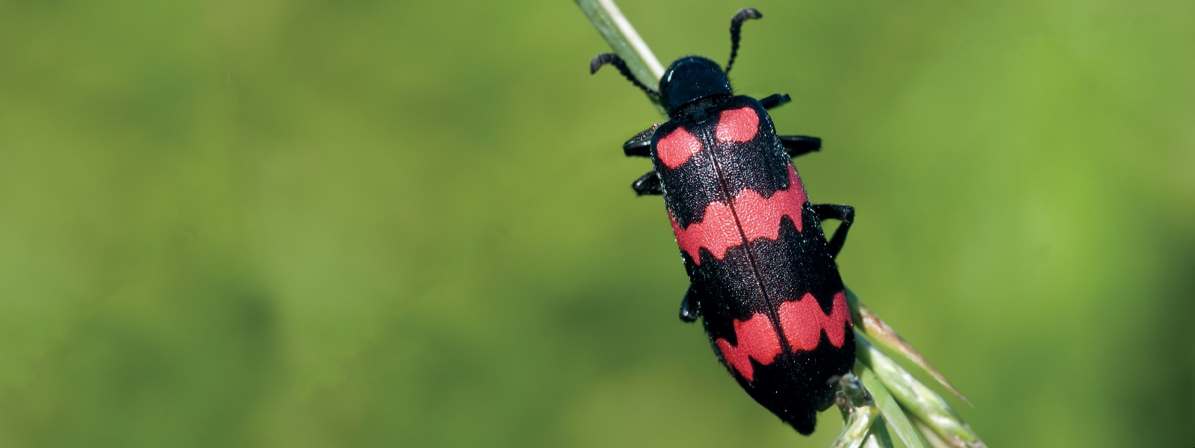
- As a medication to treat vitiligo.
- As an antidote of barbiturates.
- As bitter tonic.
- As aphrodisiac.

9. Quassia wood is famous for its use as:
- Rubefacient.
- Anthelmintic.
- Bitter tonic.
- A + C.
- B + C.
10. A friend of yours suffering from varicose veins دوالي and low-leg edema, which of the following agents is most convenient (suitable) for him?
- Sinalbin.
- Rotenone.
- Populin.
- Cocculin.
- Hesperidin.
11. Which of the following drugs prevents hyperpolarization of the cell?
- Helicin.
- Sinigrin.
- Picrotoxin.
- Santonin.

12. Which of the following plant species can be used as anthelmintic?
- Artemisia maritima.
- Citrus sinensis.
- Prunus serotina.
- Salix fragilis.
13. A patient suffering from urinary tract infections with some fluid overload (hypervolemia), which of the following plants can be of the greatest benefit for him?
- Arctostaphylos uva-ursi.
- Populus alba.
- Cornflower.
- White mustard.
14. Overall, when reacting one molecule of cinnamic acid with 3 molecules of acetate-CoA, the resultant is:
- Cyanophore glycosides.
- Glucosinolates.
- Aldehyde bitter glycosides.
- Flavonoids.
15. Which statement is FALSE regarding Butcher’s broom?
- It belongs to the Liliaceae plant family.
- It is famous for its considerable content of coumarins.
- Ruscogenin is one of the main active ingredients of the plant.
- It can be utilized in producing cortisone.
16. The hydrolysis of which phytochemical yields the compound below?
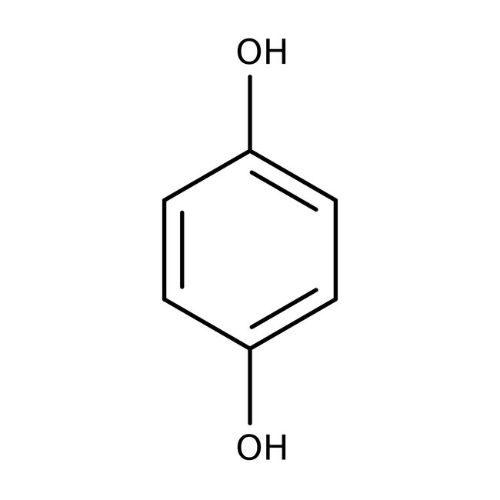
- Sinigrin.
- Medicarpin.
- Arbutin.
- Rutin.

17. Which statement is FALSE concerning this compound?
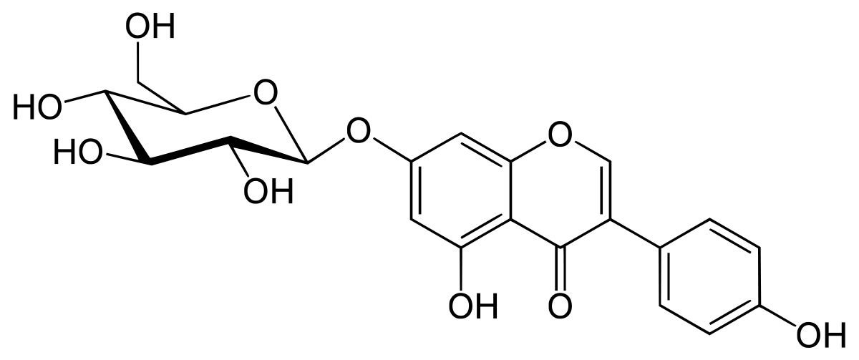
- It is an isoflavonoid.
- It is a glycoside.
- It is abundant متوفر in the leguminosae plant family.
- It has an antiatherosclerotic effect.
- It can aggravate يفاقم/يزيم من حدة postmenopausal symptoms.

* MATCH EACH ITEM FROM THE BOX BELOW WITH THE MOST SUITABLE ITEM IN QUESTIONS 18 THROUGH 22?
A. Glycyrrhizin.
B. Melacacidin.
C. Ammi visnaga.
D. Anamirta cocculus.
E. Rutin

18. Allergic skin conditions, dermatitis and dandruff. E
19. Renal colic – diuretic. C
20. Stimulant – convulsions. D
21. Licorice. A
22. Leucoanthocyanidins. B

SHORT-ESSAY QUESTIONS
II. ANSWER THE FOLLOWING QUESTIONS? {15 marks}
1. | What is rotenone used as? |  |  | 1 mark
2. | A. Name the group of this chemical?  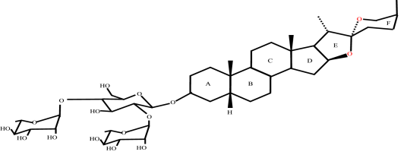  B. Give an example in nature?  C. Name a botanical source (a plant containing it) of it?  D. What can such compounds be used for? |  | A.  B.  C.  D. | 2 marks
3. | A phytotherapy practitioner recommends the spectators on TV to utilize orange peels?  Clarify how you support his recommendations? |  |  | 2 marks
4. |  | List down 2 benefits of red clover? |  | 1 mark
5. |  | What is daidzein?  What can it be used for? |  | 2 marks
6. |  | Define the term “phytoalexins”? |  | 1 mark
7. |  | List down 3 benefits of blue berry? | 1.  2.  3. | 1.5  marks
8. |  | A. What can Roselle (Hibiscus sabdariffa) be used as?  B. Clarify the mechanism of action? |  | 2 marks
9. |  | A. Flavonoids are classified as C6-C3-C6 compounds, clarify? You may draw chemical structures.  B. What is the major benefit of these compounds in medicine? |  | 2 marks
10. |  | List down 2 uses of Smilax? |  | 1 mark
11. |  | Look at the picture below and answer the questions following it?  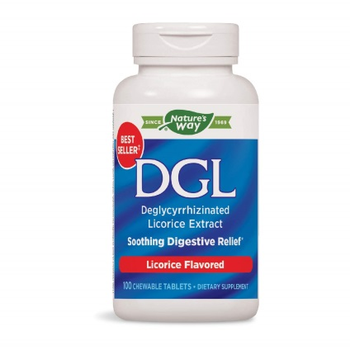  A. Interpret the acronym “DGL”?  B. Why is it formulated as DGL?  C. List down 3 benefits of this plant remedy? | A.  B.  C.  1.  2.  3. | 2.5  Marks  (each item = 0.5)
TOTAL =
16.5 marks

With best wishes of success

